|  |
| --- |
|  |
| Studies on light propagation in DCM doped PVA waveguides embedded with randomly dispersed Silica particles |
| W.RAJA VIKRAM BHATT-11PH20032 |
|  |

**UNDER THE GUIDANCE OF DR.S.N.B.BHAKTHA  
 DEPARTMENT OF PHYSICS,  
 INDIAN INSTITUTE OF TECHNOLOGY, KHARAGPUR.**

Contents

Abstract: 3

1.1. Random laser: 4

1.2 Emission Properties and Mode Structure…………………………….….......3

1.3. Applications of Random Lasers..............................................................…...4

2.1 The Theory of Transfer Matrix Method: 7

2.2. Computational Results……………………………………...……………....8

3.1. Fabrication Techniques and Experimental Details: 12

3.1.2.Addition of functionalizing agent: 13

3.2. Spin Coating: 15

3.3.1 Scanning Electron Microscopy: 16

3.3.2 Particle size distribution: 18

3.4. Preparation of PVA films and DCM dye doping: 18

4.1. Photoluminescence spectroscopy: 19  
4.2.Results…………………………………………………………………..….20

5.1. Conclusion and Scope of Future Work 21

5.2. Acknowledgements………………………………………………..………21

5.3. References…………………………………………………………...…….22

Appendix……………………………………………………………..

# Abstract:

In this project I surveyed literatures on Random Laser, Photoluminescence and presented a numerical study of the transmission properties in the 2-D corrugated waveguide using Transfer Matrix Method. In this context colloidal crystals of various thicknesses were obtained using silica particles as basic units and the Langmuir-Blodgett technique as a tool for controlling the thickness. We made thin films that were characterized by scanning electron microscopy. Particle mono-dispersity is highly dependent on the surface pressure and method of preparation. Size distribution of particles obtained using the SEM images and the particles are almost isotropic in size distribution. Poly Vinyl Alcohol (PVA)-based waveguides have been fabricated and characterized and the wave guiding action was reported. The good features of PVA films, namely they are smooth and uniform, easily dissolve in distilled water and have a high transmission (above 90% in the visible region (see figure 4 later)) makes them good candidates, for use in the field of lasing studies. PVA (Poly Vinyl Alcohol) thin films are fabricated using spin coating and dip coating methods varying different parameters (concentration and refractive index),although spin coating gave successful results and characterized using wave guiding by prism coupling method. We tried to design thin films for random lasing studies optimizing various parameters. In order to study the emission properties of short range randomized periodic structures, silica particles coated on quartz glass using Langmuir Blodgett technique. Later these films are doped with DCM {4-(Dicyanomethylene)-2-methyl-6-(4-dimethylaminostyryl)-4H-pyran} mixed with PVA in 1:3 ratio using spin coating. In the present work photoluminescence properties have been investigated.

1. Introduction to Random Lasers

# 1.1. Random laser:

Random laser works on the principle of light scattering with gain caused by intrinsic disorder of structure. Multiple scattering occurs in nearly all optical materials that appear opaque. Light rays that penetrate these materials are scattered often thousands of times in a random fashion before they exit again. This type of propagation is similar to random walk, just as in the Brownian motion of particles suspended in a liquid .The fundamental parameters describing this process are the mean free path (the average step size in the random walk) and the diffusion constant. Scattering in disordered optical materials is complex yet completely coherent. This means that the phase of each of the optical wavelets undergoing a random walk is well defined and interference effects can occur, even if a material is strongly disordered. Multiple scattering due to randomness not only occurs in natural materials, but is also intrinsically present in photonic materials, such as photonic crystals, intended for the realization of optical devices.   
  
1.2. Emission Properties and Mode Structure:   
Light diffusion with gain was already discussed theoretically by Letokhov1 in the 1960s. He argued that for a diffusion process with amplification, a situation where the total gain is proportional to the volume is obtained, whereas the losses will be proportional to the total surface. It is then easy to see that there exists a critical volume above which gain becomes larger than loss, and the intensity diverges. If the gain depends on wavelength, this model also predicts that the emission spectrum narrows down above threshold with a maximum intensity at the wavelength of maximum gain. In addition, relaxation oscillations as well as laser spiking can be found in such a diffusive model. Several of these features have indeed been observed in experiments. Briskina2 and co-workers and later Migus3 and co-workers made a disordered amplifying material by grinding laser crystal into a fine powder. They managed to excite this powder optically and achieve optical gain through stimulated emission together with multiple scattering. Above a certain threshold gain level, the emission spectrum was observed to narrow down and the peak intensity to increase. A different strategy to achieve multiple scattering with gain was followed by Lawandy4 et al., who suspended micro particles in laser dye. The advantages of such a material are that the amount of scattering can easily be varied by changing the particle concentration. Modes in a regular laser are determined by the laser cavity and usually consist of standing-wave patterns. In a random laser, the spatial profile of the modes is dominated by a speckle pattern with a gradually varying envelope. This interference plays an important role in all random-laser materials that have been studied so far, including the first structures realized.

In this context, the relation between random lasing and amplified spontaneous emission can also be understood. Amplified spontaneous emission is light that originates from spontaneous emission and that is subsequently amplified by stimulated emission. This process takes place without an optical cavity and can therefore occur even in completely transparent active materials where rays can propagate freely. The spectrum of amplified spontaneous emission is determined by the gain curve of the active material. Owing to the stimulated emission process, this light can even become highly coherent under certain conditions .Amplified spontaneous emission is often classified as lasing without mirrors. In a random laser, on the other hand, the multiple scattering processes define optical modes with a certain central frequency and bandwidth. 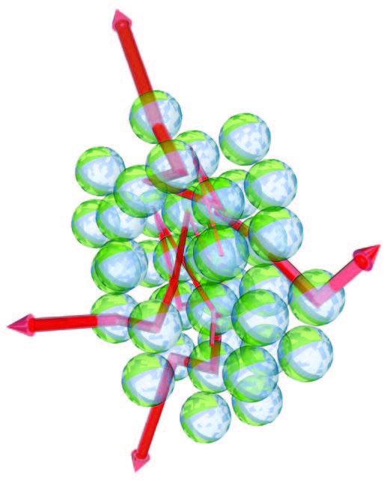   
  
  
1.3. Applications:A major advantage of random laser is that its production is cheap and relatively simple. In addition the materials can be produced on a large scale and have high efficiency. A particular advantage of random-laser materials is that they can be prepared in the form of suspensions of particles that can be applied as coatings on surfaces of arbitrary shape. It has interesting potential for environment lighting, for example, in the form of street lighting that is applied directly on the road. Such a coating can also be applied to road vehicles, ships and aircraft. The same technology has been patented for use in the identification of friendly/enemy vehicles.  
The properties that make a random laser special in respect to regular lasers are its colour and angular dependence, as well as its complex features in emission spectra. The angular distribution of the output of a random laser is very broad and can be distributed over the complete solid angle of 4π. This broad angular emission is in principle ideal for display applications. However, to develop such applications it is crucial to have electrical control over the emission. It was found by Gottardo4 et al. that this directionality can indeed be electrically tuned by realizing a random laser from a polymer-dispersed liquid crystal, a material commonly applied to realize liquid-crystal.

**Figure 1   
Multiple light scattering with gain. A random collection of microspheres containing laser dye is excited (for example, by an external light source) to obtain population inversion. The microspheres then scatter light and amplify it in the process. The propagation of the light waves becomes that of an amplified random walk.(Image take from Ref.5.)**

Recently, an application was proposed for random lasers in a very different area, namely that of medical diagnostics. Vardeny5 and co-workers found that the emission spectrum of cancerous human tissue, when doped with laser dye, could be distinguished from healthy tissue. This would enable an alternative strategy for tumour diagnostics. The result links to the very active field of biomedical imaging with diffuse light and makes use of the fact that different tissue and bone types have different optical structures and mean free paths.

In addition to electrical control over random-laser emission, temperature tuning has been demonstrated as well. In this case, the random-laser spectrum depends strongly on environment temperature and the random laser can even be brought above and below threshold by temperature changes. This can be applied for remote temperature sensing in hostile environments by inserting a grain of random-laser material in the environment and probing its emission spectrum remotely with a telescope. In addition, this property can be applied to create coatings of which the colour is temperature dependent and, for example, smart windows with different optical properties in summer/winter seasons.  
In this context we decided to perform computational analysis of transmission properties of the 2-D surface corrugated waveguides for random lasing. But it can be simplified as a waveguide consisting of randomly refractive index modulated thin layers and numerically studied with Transfer Matrix Method.

2. TRANSFER MATRIX METHOD

# 2.1 The Theory of Transfer Matrix Method:

A medium whose properties are constant throughout each plane perpendicular to a fixed direction is called a stratified medium. If z-axis is the special direction then the dielectric constant and the permeability will be functions of z, ε (z) and μ (z). Theory of stratified medium is of significant importance in connection to multilayer. The problem of transmission and reflection properties of multilayer can most conveniently be expressed in terms of matrices. To introduce the transfer matrix method, firstly we consider a general case of plane wave propagation on both sides of a dielectric interface. The electric fields can be written as,

For medium 1,

For medium 2,

Where A1, A2 are amplitudes of right travelling waves (along +x direction) and B1, B2 are the amplitudes of left travelling waves (-x direction). Β is the z component of the wave vector and is same in both the medium as the structure is homogeneous along z direction.  
The problem is how the amplitudes on the both sides of the interface are related to each other. The components of the wave vectors are related in the following way,

;

Now, the amplitudes are related as follow,

;

where r12, t12, r21 and t21 are the Fresnel transmission and reflection coefficients. From the above equations it can be written that,

;

As we know the Fresnel coefficients satisfy,

;

Therefore from above

+

Or in term of matrices,

; Or

The 2×2 matrix T12 is defined as the Transition matrix inlayers 1 and 2. The Transition matrix is a symmetric matrix. Now, we need a matrix for propagation from one end of the homogeneous layer to the other end. If the homogeneous medium is of thickness ‘d’ and refractive index ‘n’ then a phase shift will be introduced as, φ = kxd = (nωd/c) cosθ. The matrix representation will be

;

Where A’, B’ are the field amplitudes at the right end and A, B are the field amplitudes at the left end of the medium. The diagonal matrix P is defined as the Propagation matrix. So, for lossless medium P is unitary matrix. The Transition matrix depends on state of polarization but Propagation matrix does not. The Transition matrix T and the Propagation matrix can now be employed to treat a general multilayer structure like in Fig 2.1.

n1 n2 n3

T01 P1 T12 P2 T23 P3 T34

Fig2.1: Generalized structure of multilayer

Corresponding matrix equation can be written as,

or

where M04 is the characteristic matrix of the stratified medium. The matrix equation can be easily simplified with substituting the values of Fresnel reflection and transmission coefficient. The characteristic matrix for a single layer for TE mode can be written as

In the above equation θ is the incident angle of the wave. Similarly for TM mode it can be written as,

With the help of matrix multiplication one can obtain the characteristic matrix for the complete layered structure. Now, if M is written as,

If θi and θf are the angle of incidence and angle of emergence respectively, then the reflectivity of the stratified medium can be written as,

The above equation for calculation of reflectivity is a general form for both TE and TM mode. Corresponding matrix elements will be changed for the two mode of propagation.  
  
Computational Results:  
In this project, we modified the simulation process further for simplification by keeping the refractive indices of the alternating layers as constants (*n*1 = 1.43, *n*2 = 1.90; here *n*1 and *n*2 are the effective refractive indices of TE0 mode of the waveguide), but let the thickness of each layer be random between 75 nm to 120 nm. The modification should give the same simulation result as optical path *n* X *L* is the effective physical element (*n* refractive index, L thickness of layer).

|  |  |
| --- | --- |
|  |  |
|  |  |
|  |  |
|  |  |

**Figure.2.a)In the above figure left side of the plots had shown the results for randomly varying the thickness and summing the results over 2000 ensembles for 100, 200 300,400 and 500 layers respectively. Right side of the plots shown had shown for keeping the thickness of each layer kept constant and averaging the result over 2000 ensembles in the same order respectively.**Our numerical results indicate that for generally anisotropic layered systems the addition of number of ensemble causes the system to smoothen it and causing various modes to form. As the thickness parameter for every single case follows Gaussian distribution we can notice that reflectivity doesn’t change much but it varies considerably over fixed length system.

We noticed the formation of photonic band gaps (where reflectivity is 100%) over certain wavelength ranges. Thus we know that the whole structure can be considered as many minicavities formed by the feedback of different parts of the structure and more modes can be localized with the increasing of the structure length.

These band gaps remain fixed but with increased number of layers and randomness there are additional modes which have been noticed to increase significantly. For each ensemble with randomly varying thickness the reflectivity doesn’t change much but smoothening of modes has been observed with summing over higher number of ensembles.

# 

3. Fabrication and Characterization Techniques

# 3.1. Fabrication Techniques and Experimental Details:

Prior to coating the silica particles on the surface of glass substrate have been already prepared using modified Stober method. A brief explanation of the preparation procedure has been given:   
  
3.1.1.Stober Method:  
The Stober is used for preparing monodispersed colloidal silica particles. It provides a good controlled growth over uniform particle size of silica particles by means of hydrolysis of alkyl silicates and subsequent condensation of silicic acid in alcoholic solutions using ammonia as morphological catalyst. The diameter of silica particles from the Stober process is controlled by the relative contribution from nucleation, growth processes and temperature of the reaction. The hydrolysis and condensation reactions provide precursor species and the necessary super saturation for the formation of particles. During the hydrolysis reaction, the ethoxy group of TEOS reacts with the water molecule to form the intermediate [Si (OC2H5)4-x (OH) x] with hydroxyl group substituting ethoxy groups. Ammonia works as a basic catalyst to this reaction; the hydrolysis reaction is initiated by the attacks of hydroxyl anions on TEOS molecules 2006). The chemical reaction is expressed as follows

***Si(OC2H5 )4+x H2O→ Si(OC2H5 )4-x (OH)x + xC2H5OH***

Following the hydrolysis reaction, the condensation reaction occurs immediately. Where the hydroxyl group of intermediate [Si (OC2H5)4-X (OH)X] reacts with either the ethoxy group of other TEOS “alcohol condensation” or the hydroxyl group of another hydrolysis intermediate “water condensation” to form Si-O-Si bridges. Both the condensation reaction can be expressed as follows.

The overall reaction is expressed as follows:

Silica nanoparticles were prepared by hydrolysis and condensation of TEOS (Tetra ethyl orthosilicate) in ethanol, and in presence of ammonia as catalyst. First, solution containing appropriate quantities of absolute ethanol, ammonia and de-ionized water were stirred for 5 minutes to ensure complete mixing. Then a proper amount of TEOS in absolute ethanol was added to the above solution and the reaction proceeded at ambient temperature for 24 hours.

3.1.2Addition of functionalizing agent:  
Allyltrimethoxysilane was added to functionalize the silica surface. The choice of this compound was driven by the following reasons. First, the surface of the particles should not be too hydrophilic; else an aggregation phenomenon occurs in the solution before spreading. On the other hand if the particles are too hydrophobic, the dispersion is easy but the particles aggregate at the air-water interface. In both cases, the degree of organization of the particles at the interface is too low to form well-organized colloidal arrays.  
  
3.1.3. Langmuir Blodgett Technique:

Essentially all LB film works begin with the Langmuir-Blodgett trough, or Langmuir film balance, containing an aqueous sub phase. Moveable barriers that can skim the surface of the sub phase permit the control of the surface area available to the floating monolayer.

To form a Langmuir monolayer film, the molecules of interest is dissolved in a volatile organic solvents (chloroform, hexane, toluene etc.) that will not dissolve or react with the subphase. The dilute solution is then minutely placed on the subphase of the LB trough with a micro litre syringe. The solvents evaporate quickly and the surfactant molecules spread over the subphase surface in the LB trough.

In order to control and monitor the surface pressure, π (this quantity is the reduction of surface tension below that of clean water), the barrier intercepting the air-water interface is allowed to move so as to compress or expand the surface film. Wilhelmy plate arrangement is used to measure the surface pressure. In this method a small piece of hydrophilic material, usually filter paper, intercepting the air-water interface and supported from the arm of an electronic microbalance which is interfaced with a computer. The force exerted is directly proportional to the surface tension. There are several techniques available to monitor the state of the floating monolayer.

The measurement of surface pressure (π) as a function of area per molecule (A) in the monolayer films is known as the isotherm characteristics. This characteristic is easily obtained and much useful information about the mono molecular films at the air-water interface. 

**Fig.3.1.A conceptual illustration of the surface pressure versus area per molecule isotherm is shown in figure. (Image taken from Ref.6.)**

As the pressure increases, the two dimensional monolayer goes through different phases that have some analogy with the three dimensional gas, liquid, and solid states. If the area per molecule is sufficiently high, then the floating film will be in a two-dimensional gas phase where the surfactant molecules are not interacting. As the monolayer is compressed, the pressure rises signalling a change in phase to a two-dimensional liquid expanded (LE) state, which is analogous to a three dimensional liquid.

Upon further compression, the pressure begins to rise more steeply as the liquid expanded phase gives way to a condensed phase, or a series of condensed phases. This transition, analogous to a liquid–solid transition in three dimensions, does not always result in a true two dimensional solid. Rather, condensed phases tend to have short-range structural coherence and are called liquid condensed (LC) phases. If the surface pressure increases much further the monolayer will ultimately collapse or buckle, not still being a single molecule in thickness everywhere.  
The appealing feature of Langmuir- Blodgett films is the intrinsic control of the internal layer structure down to the molecular level and the precise control over the resulting film thickness. Sophisticated LB troughs allow us to process several materials with different functionalities and offer the possibility to tune the layer architecture according to the demands of the desired molecularly engineered organic thin film devices.

# 3.2 Spin Coating:

Spin coating is a procedure used to apply uniform thin films to flat substrates. An excess amount of the sol is placed on the substrate, which is then rotated at high speed in order to spread the fluid by centrifugal force. The spin coating technique consists of four basic steps

Step 1: The fluid is dispensed onto the substrate by a nozzle. Amount of the fluid should be sufficient, so that it can cover the whole surface of the substrate. Another important issue is whether the fluid wets the surface completely during the dispensing steps. If not incomplete coverage will result.

Step 2: The substrate is then accelerated towards its final speed. Due to centrifugal force the fluid is moved radially outward. Expulsion of fluid, from the substrate surface takes place.

Ultimately, the wafer reaches its desired speed and the fluid is thin enough that the viscous shear drag exactly balances the rotational accelerations.

Step 3: The substrate is rotated at its final constant speed. In this step, viscosity of the fluid dominates fluid thinning behaviour. Thickness of the fluid decreases gradually. The final speed of rotation depends on the property of the fluid. To obtain a thinner film for a high viscous fluid, the substrate should be rotated at higher speed or for longer time.  
  
Step 4: In the final stage, when the substrate is rotated at constant speed evaporation of solvent takes place and this dominates the thinning behaviour of the coated film.

Advantages of spin coating: It is low cost and less time consuming technique. It is less complicated to operate. Film thickness can be easily changed by changing spin speed and spinning time.   
Disadvantages: Film thickness is not uniform. During spinning most of the  
liquid (sol) is flung off from the substrate and wasted.  
  
3.3 Experimental Parameters:

Prior to experiment the whole setup is wiped with tissue paper using acetone and the glass sides scrubbed with acetone and ethanol so as to remove dust particles. The Langmuir trough is filled with water and it’s been compressed and expanded several times to collect the dust particles and removed them using vacuum pump such that the surface pressure lies around 0.4mN/mm.

The colloidal silica solution is then treated with 80% chloroform and 20% ethanol by volume and ultra sonicated up to 30 minutes so as evenly disperse the silica particles in the solution. We injected silica particles solution into the subphase using micro litre syringe until the surface pressure reaches ambient pressure we can start along. The experimental setup is then compressed and expanded with 3cm/min speed until the surface pressure reached the desired value.

In our project we made nine thin films each set of three samples at 9mN/mm, 18mN/mm and 27mN/mm. We adjusted the values of down stroke and upstroke of substrate (glass slide) in subphase (water) speed as 6mm/min such that at the end of each cycle we coated two layers on the glass substrate.  
Initially, rate deposition of the particles during the transfer could strongly depend on the interactions between the substrate and the liquid film of particles. To obtain colloidal crystals with the best possible quality through the LB technique, it is obvious that the elaboration of a 2D array of particles at the air-water interface is a key point. Considering other experiments not presented here, one can say that the organization at the interface is strongly dependent on the functionality and the size of the silica particles.

3.3.1 Scanning Electron Microscopy:  
SEM observations are performed with ZEISS EVO 60 Analytical Scanning Electron Microscope with Oxford EDS Detector. The Microscope works with tungsten filament and maximum acceleration voltage of 30 kV. The specimens were gold coated prior to the examination.  
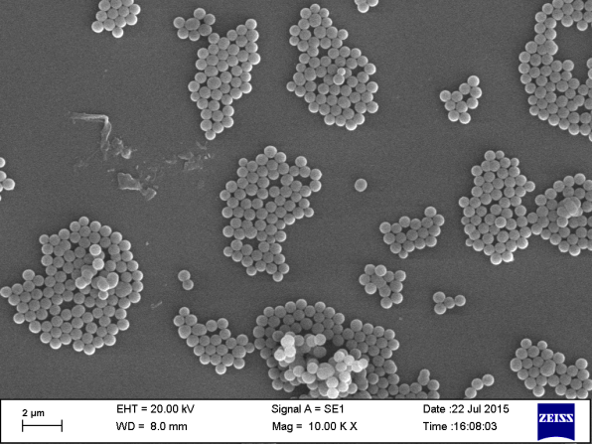 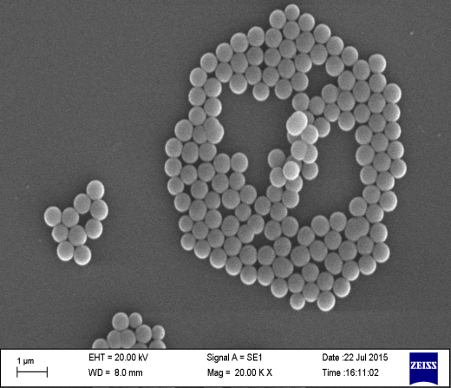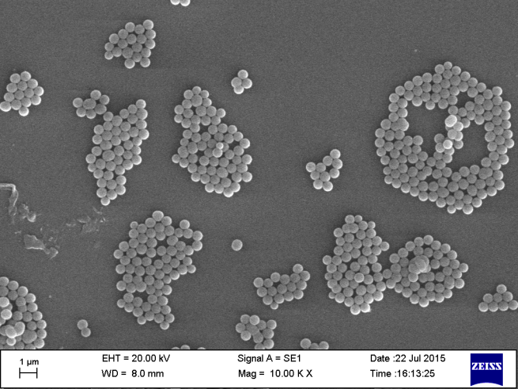 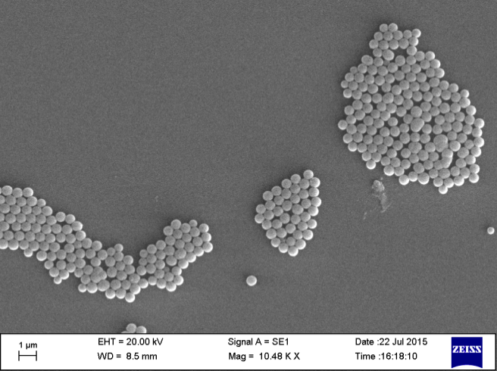

**Figure.3.2. Top view of functionalized silica particles transferred on glass slide (Particle size 630nm) at 18mN/mm.**

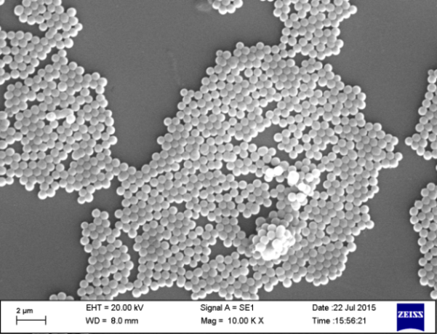 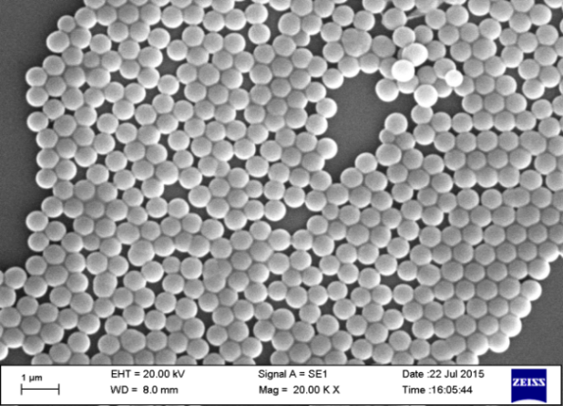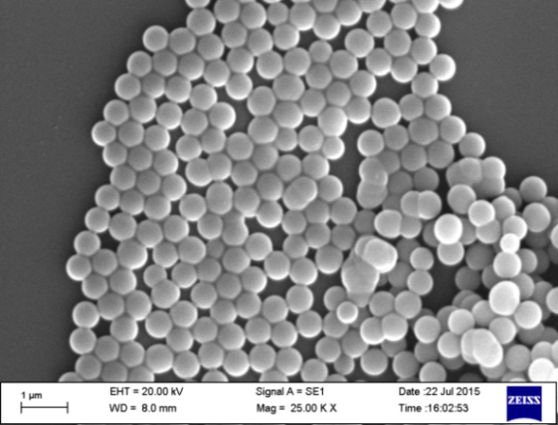 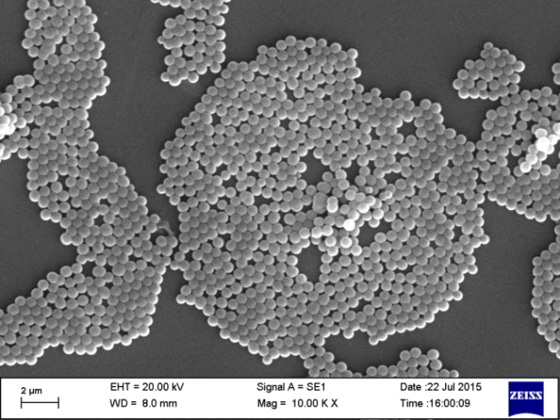

**Figure.3.3. Top view of silica particles formed at 27mN/mm** **which shows good packing quality but formation of aggregates noticed.**

# 3.3.2.Particle size distribution:

# 3.4. Preparation of PVA films and DCM dye doping:

**Figure.3.4.   
Histogram distribution of particle size obtained from SEM images for sample size of 100 particles. The origin of distribution is due to highly temperature dependence of Stober method.**

PVA (Poly Vinyl Alcohol) solutions are first prepared by trial and error method at different concentration. In order to waveguide properly the substrate (in our case quartz or glass) refractive index has to be less than the PVA films coated.  
As it was mentioned in work of Rajesh Kumar et.al5, minimal concentrations exist above which wave guiding occurs.

PVA solutions has been prepared using water as solvent in 20%(w/v) ratio and stirred at 600RPM at 750C using magnetic stirrer until a clear viscous solution has been formed. DCM solution has been prepared using methanol as solvent (0.0062gm of DCM + 10ml of methanol and the solution has been stirred at 600RPM and 400C until clear solution has been formed. PVA and DCM solutions are mixed in 3:1 ratio of volume respectively. In order to investigate the particle packing density effect, previously coated silica particles on Quartz glass been doped with PVA+DCM solution using spin coating method.

4. PHOTOLUMINSCENE STUDIES

# 4.1. Photoluminescence spectroscopy:

Photoluminescence (PL) is the spontaneous emission of light from a material under optical excitation. The excitation energy and intensity are chosen to probe different regions and excitation concentrations in the sample. PL investigations can be used to characterize a variety of material parameters. PL spectroscopy provides electrical (as opposed to mechanical) characterization, and it is a selective and extremely sensitive probe of discrete electronic states. Features of the emission spectrum can be used to identify surface, interface, and impurity levels and to gauge alloy disorder and interface roughness. The intensity of the PL signal provides information on the quality of surfaces and interfaces. Under pulsed excitation, the transient PL intensity yields the lifetime of non-equilibrium interface and bulk states. Variation of the PL intensity under an applied bias can be used to map the electric field at the surface of a sample. In addition, thermally activated processes cause changes in PL intensity with temperature. PL analysis is non-destructive. Indeed, the technique requires very little sample manipulation or environmental control. Because the sample is excited optically, electrical contacts and junctions are unnecessary and high-resistivity materials pose no practical difficulty. In addition, time-resolved PL can be very fast, making it useful for characterizing the most rapid processes in a material. The fundamental limitation of PL analysis is its reliance on radiative events. Materials with poor radiative efficiency, such as low-quality indirect band gap semiconductors, are difficult to study via ordinary PL. Similarly, identification of impurity and defect states depends on their optical activity. Although PL is a very sensitive probe of radiative levels, one must rely on secondary evidence to study states that couple weakly with light.  
  
The choice of excitation is critical in any PL measurement. The excitation energy and intensity will have profound effects on the PL signal. Although the excitation conditions must be considered carefully, the strength of the PL technique relies heavily on the flexibility that these adjustable parameters provide. Because the absorption of most materials depends on energy, the penetration depth of the incident light will depend on the excitation wavelength. Hence, different excitation energies probe different regions of the sample. The excitation energy also selects the initial excited state in the experiment. Because lasers are monochromatic, intense, and readily focused, they are the instruments of choice for photoluminescence excitation (PLE). Unlike the excitation energy, which may or may not be important, the excitation intensity will influence the result of any PL experiment. The excitation intensity controls the density of photo excited electrons and holes, which governs the behaviour of these carriers. Each electron–hole recombination mechanism has a distinct functional dependence on carrier density. For example, the number of interface and impurity states is finite, and recombination at these sites will saturate at high excitation. In addition, the photo excited carriers themselves can alter the distribution of interface states. Thus, the excitation intensity must be calibrated accurately and controlled precisely.

# Results:

We excited the dye DCM doped PVA film with Nd:YAG pulse, Q-switched nano-laser in second harmonic frequency 532nm with 70% of power(8.192mJ).Given below is the PL spectrum of film made at 27mN/mm.  
  
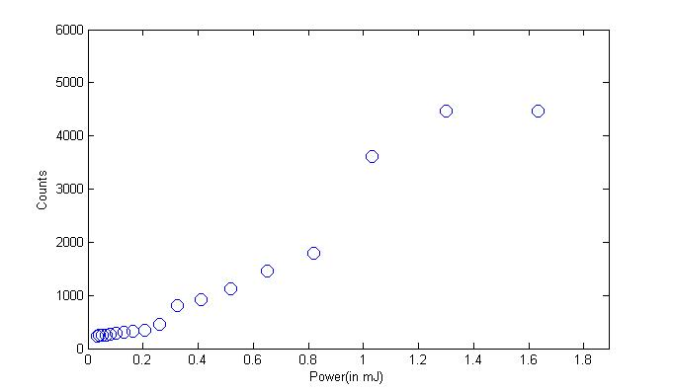 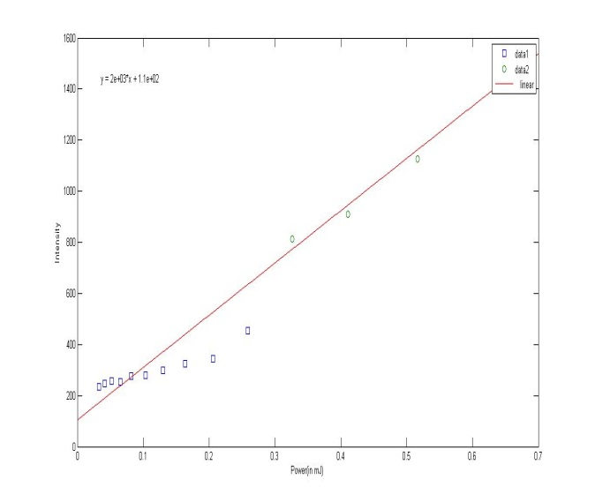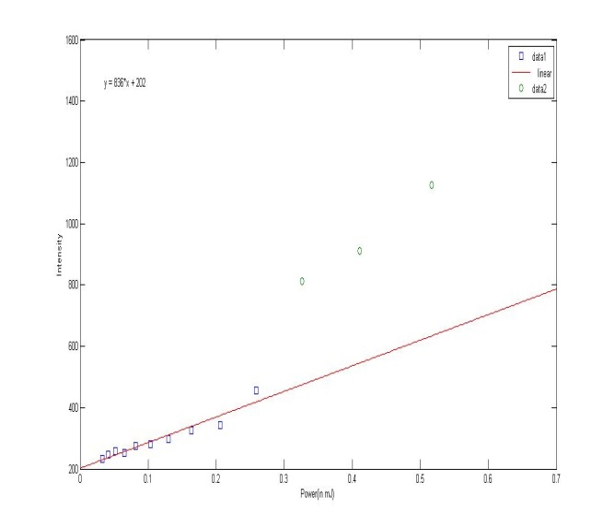

**Figure.5.1. Peak intensity vs power of thin film fabricated at 27mN/mm and dope with 1:3 DCM+PVA. We can notice two different regions in the lower side are spontaneous emission and upper corner side which correspond to stimulated emission.**

**Figure.5.2.Estimation of threshold lasing power value. In the left side plot linear fit has been drawn for upper side (stimulated emission).In the right plot linear fit drawn for lower side (spontaneous region). Their intersection correspond to lasing threshold value, estimated as 0.0079mJ.**

# **5.1. Conclusion and Future Scope of Work:**

We have demonstrated that functionalized silica particles can be organized in colloidal crystal through Langmuir Blodgett technique. Using Langmuir Blodgett technique we coated colloidal thin films of well-defined thickness made of silica particles of size 600-630nm.The main advantage of this method is control of thickness in perfectly reasonable amount of time. The organization of particles on the surface is highly dependent on pressure and the functionalizing agent. SEM observations illustrate high degree of organisation of silica particles but we spotted some formation of aggregates on the surface.  
We extended further our work of thin film by coating silica particles on dye doped PVA matrix to study the photoluminescence properties of the random lasing waveguides. Emission properties of silica thin films formed at various surface pressures and doped with DCM and PVA has been investigated and threshold lasing power estimated.  
  
5.2. Acknowledgements:   
I am highly indebted to Prof.S.N.B.Bhakta for his guidance and constant supervision as well as for providing necessary information regarding the project, enthusiastic encouragement, useful critiques of this research work and also for his support in completing the project.  
I would like to express my special gratitude and thanks to Mr.Anirban Sarkar,Mr.Subratha Ghosh,Ms.Ojha Subhashree and Ms.Pratyusha Das for helping me throughout the project and giving me such attention and time.  
  
5.3. References:

1. Letokhov, V.S. Generation of light by a scattering medium with negative resonance absorption. Zh. Eksp. Teor. Fiz. 53, 1442–1447 (1967); Sov. Phys. JETP 26, 835–840 (1968).  
2. Markushev, V. M., Zolin, V. F. & Briskina, Ch. M. Powder laser. Zh. Prikl. Spektrosk. 45,847–850 (1986).  
3. Lawandy, N. M., Balachandran, R. M., Gomes, A. S. L. & Sauvain, E. Laser action in strongly scattering media. Nature 368, 436–438 (1994).  
4. Wiersma, D. S. (2008). The physics and applications of random lasers. Nature physics, 4(5), 359-367.  
5. Hussain, S. A. (2009). Langmuir-Blodgett Films a unique tool for molecular electronics. *arXiv preprint arXiv:0908.1814*.  
6. Reculusa, S., & Ravaine, S. (2003). Synthesis of colloidal crystals of controllable thickness through the Langmuir-Blodgett technique. Chemistry of materials, 15(2), 598-605.  
7.Pratyusha Das,Dept. of Physics, Indian Institute of Technology, Kharagpur, M.Tech Thesis, Synthesis and Characterization of hetero colloidal structures for optical electronics.  
8. Gfroerer, T. H. (2000). Photoluminescence in analysis of surfaces and interfaces. Encyclopedia of analytical chemistry.  
9. Yokoyama, S., Otomo, A., & Mashiko, S. (2002). Laser emission from high-gain media of dye-doped dendrimer. Applied physics letters, 80(1), 7-9.  
10. Kumar*, R., Singh, A. P., Kapoor, A., & Tripathi, K. N. (2005). Effect of dye doping in poly (vinyl alcohol) waveguides. Journal of Modern Optics, 52(10), 1471-1483.  
11. Cerdán, L., Costela, A., Enciso, E., & García‐Moreno, I. (2013). Random Lasing in Self‐Assembled Dye‐Doped Latex Nanoparticles: Packing Density Effects. Advanced Functional Materials, 23(31), 3916-3924.

Appendix:  
Code for TMM with randomly varying thickness   
%%%%Data initialization

ni=1;

nf=1;

thetai = 0; % angle of incidence

lambdaMed = 6.500742034896100e+02; % central wavelength

DeltaLambda = 9.002929992707800e+02; %observed region of wavelengths

nLambda = 2730;%(point-1)

numeroStrati= 500; % number of layers

n1=1; % R.I. of medium "1"

n2=1.4585; % R.I. of medium "2"

t1= 540; % thickness of medium "1" (nm)

t2= 580; % thickness of medium "2"(nm)%

%lRand=0; %gaussian random variation of thickness

%tdef=188.7;

%ndef=1.55;

FrazTE=1; %Fraction of the incident wave with TE polarization

a=zeros;

t=zeros;

n=zeros;

S=0;

% calculation of various parameters

lambda = lambdaMed-DeltaLambda/2:DeltaLambda/nLambda:lambdaMed+DeltaLambda/2;

theta1 = asin(ni/n1*sin(thetai));

theta2 = asin(ni/n2*sin(thetai));

thetaf=asin(ni/nf*sin(thetai));

rng('shuffle'); % exchange generator of randomnumbers %randn == pseudorandom values from standard normaldistribution

for m=1:2

S=0;

for j=1

lRand=m;

% definition of structure

for k = 1:numeroStrati

n(k)= ((-1)^k+1)*n2/2+(1-(-1)^k)*n1/2;

%a(k)=randn(1)*lRand;

if rem(k,2)==0

t(k)= ((-1)^k+1)*t2/2+(1-(-1)^k)*t1/2 - (t2-t1)*rand(1);

else

t(k)= ((-1)^k+1)*t2/2+(1-(-1)^k)*t1/2 +(t2-t1)*rand(1);

%+ a(k);

end

theta(k)=((-1)^k+1)*theta2/2+(1-(-1)^k)*theta1/2;

end

%d=floor((numeroStrati+1)/4)*2+1; %rounding down to the nextsmaller integer

%t(d)=tdef + a(d);

%n(d)=ndef;

%%%%% Initialization of ME and MM

for z=1:nLambda+1;

ME(:,:,z)=eye(2);

MM(:,:,z)=eye(2);

end

for k= 1:numeroStrati;

%characteristic matrix for single layer (TE)

Mke(1,1,:)=cos(2*pi./lambda*n(k)*t(k)*cos(theta(k)));

Mke(1,2,:)=-1i/(n(k)*cos(theta(k)))*sin(2*pi./lambda*n(k)*t(k)*cos(theta(k)));

Mke(2,1,:)=-1i*(n(k)*cos(theta(k)))*sin(2*pi./lambda*n(k)*t(k)*cos(theta(k)));

Mke(2,2,:)=cos(2*pi./lambda*n(k)*t(k)*cos(theta(k)));

%characteristic matrix for single layer (TM)

Mkm(1,1,:)=cos(2*pi./lambda*n(k)*t(k)*cos(theta(k)));

Mkm(1,2,:)=-1i/(cos(theta(k))/n(k))*sin(2*pi./lambda*n(k)*t(k)*cos(theta(k)));

Mkm(2,1,:)=-1i*(cos(theta(k))/n(k))*sin(2*pi./lambda*n(k)*t(k)*cos(theta(k)));

Mkm(2,2,:)=cos(2*pi./lambda*n(k)*t(k)*cos(theta(k)));

for z=1:nLambda+1;

%M(1,1,z)= M(1,1,z).*Mk(1,1,z)+ M(1,2,z).*Mk(2,1,z)

%M(1,2,z)= M(1,1,z).*Mk(1,2,z)+ M(1,2,z).*Mk(2,2,z)

%M(2,1,z)= M(2,1,z).*Mk(1,1,z)+ M(2,2,z).*Mk(2,1,z)

%M(2,2,z)= M(2,1,z).*Mk(1,2,z)+ M(2,2,z).*Mk(2,2,z)

ME(:,:,z)=ME(:,:,z)*Mke(:,:,z);

MM(:,:,z)=MM(:,:,z)*Mkm(:,:,z);

end

end%%%%%%% %%%%%%%%%%%%% %%%%%%

% Results

R_TE (:,j) = abs(((ME(1,1,:) +ME(1,2,:).*nf*cos(thetaf))*ni*cos(thetai)-(ME(2,1,:)+ME(2,2,:).*nf*cos(thetaf)))./((ME(1,1,:)+ME(1,2,:).*nf*cos(thetaf))*(ni*cos(thetai))+ (ME(2,1,:) +ME(2,2,:).*nf*cos(thetaf)))).^2;

R_TM (:,j)= abs(((MM(1,1,:) +MM(1,2,:)./nf*cos(thetaf))/ni*cos(thetai)-(MM(2,1,:)+MM(2,2,:)./nf*cos(thetaf)))./((MM(1,1,:)+MM(1,2,:)./nf*cos(thetaf))/(ni*cos(thetai))+ (MM(2,1,:) +MM(2,2,:)./nf*cos(thetaf)))).^2;

S = S + R_TE(:,j);

R =R_TE*FrazTE+R_TM*(1-FrazTE);

T_TE = 1-R_TE;

T_TM = 1-R_TM;

T=1-R;

end

P(:,m)=S(:)/1000;

figure(m)

plot(lambda,P(:,m));

xlabel('wavelength(in nm)'); ylabel('Reflectance');

end